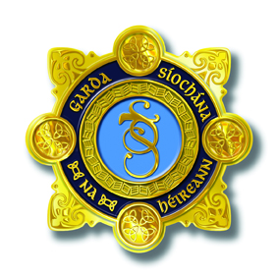

An Garda Síochána

6th ANNUAL ROSCOMMON/LONGFORD GARDA YOUTH AWARDS 2024

In association with Roscommon & Longford County Councils

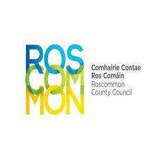
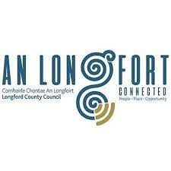
Recipients will be notified by the Organising Committee following the judging in August 2024.

Inside: Details of the competition
Application Form
Rules of the competition
GARDA NATIONAL YOUTH AWARDS 2024

YOUR DETAILS (NOMINATOR)

ROSCOMMON/LONGFORD DIVISION
DIVISION:
NOMINATOR’S NAME:

ADDRESS:

TELEPHONE NO:

CLUB / ORGANISATION / PERSONAL:

EMAIL:

DETAILS OF THE INDIVIDUAL OR GROUP THAT YOU ARE NOMINATING, AND THE AWARD CATEGORY
NOMINEE’S NAME:

ADDRESS:

TELEPHONE NO:

AWARD CATEGORIES

All categories are for young people aged between 13 and 21 years.

INDIVIDUAL AWARD:
Making a positive contribution to their community, making it a better place to live.

GROUP AWARD:
Groups of 2 or more, making a positive contribution to their community, making it a better place to live.

SPECIAL ACHIEVEMENT AWARD:
Overcome difficult circumstances, defied all the odds, and whose commitment deserves recognition.

COMMUNITY SAFETY AWARD:
Through a crime prevention or safety initiative / innovation, have made their community a safer place to live.

FOR INDIVIDUAL AWARD AND GROUP AWARD NOMINATIONS,
PLEASE PROVIDE DETAILS AS REQUESTED IN SECTION A.

FOR SPECIAL ACHIEVEMENT AWARD NOMINATIONS,
PLEASE PROVIDE DETAILS AS REQUESTED IN SECTION B.

FOR COMMUNITY SAFETY AWARD NOMINATIONS,
PLEASE PROVIDE DETAILS AS REQUESTED IN SECTION C.

SECTION A. INDIVIDUAL AND GROUP AWARD NOMINATIONS.

- Please outline how this young person / group has made a positive contribution to their community, making it a better place to live. (Maximum of 100 words.)

- Please outline how this young person / group has shown the spirit of volunteerism. How have they been selfless and dedicated in their actions, without expecting anything in return.
(Maximum of 100 words.)

- Please describe how the young person / group has promoted a positive image of young people throughout the community. (Maximum of 100 words.)

- How have the young person’s/ group’s efforts benefited the community? (Maximum of 100 words.)

- Please describe how the young person / group been a positive role model for others, and gone above and beyond what is required of a young person? (Maximum of 100 words.)

SECTION B. SPECIAL ACHIEVEMENT AWARD NOMINATIONS.

- Please outline what difficult personal circumstances the young person has had to overcome in their lives. (Maximum of 100 words.)

- Please outline how this young person has demonstrated personal growth and endurance in the face of these difficulties. (Maximum of 100 words.)

- Please outline how the young person’s efforts and contribution have made a difference in the community. (Maximum of 100 words.)

- Please outline how many people have been affected by the young person’s contribution. Please indicate how many people have been affected, and how they have been affected. (Maximum of 100 words.)

- Please describe how their actions have been a source of inspiration to others. (Maximum of 100 words.)

SECTION C. COMMUNITY SAFETY AWARD NOMINATIONS.

- Please outline how this young person set about identifying a safety issue within their community.
(Maximum of 100 words.)

- Please outline why the young person decided upon this particular issue, and if they carried out any additional research in advance of their work.
(Maximum of 100 words.)

- Please outline how this young person / group has made a positive

- Please outline what steps the young person took in order to address this issue. What did their work involve? Please provide details of the project.
(Maximum of 100 words.)

- Please describe how the young person displayed enthusiasm, passion and creativity in the course of their work on this project.
(Maximum of 100 words.)

- Please outline the impact the work of this young person has had on their community. Please provide details of any specific benefits to the community as a result of the young person’s work.
(Maximum of 100 words.)

RULES OF THE COMPETITION

- Awards are confined to those young people who are aged between 13 and 21 years on 31st August 2024.

- Permanent residence of the young person must be in the Garda Division in which they are nominated.

- Awards are confined to individuals and groups of two or more people.

- Judges decision is final.

- The Judging Panel will decide upon one nominee in each category to go forward to represent the Division at the National Garda Youth Awards.

- Any member of the public may nominate anyone whom they feel deserves an award.

- Nominations may be submitted by family members or relatives.

- Previous award winners are not eligible.

- In exceptional circumstances the Judging Panel have the autonomy to present Special Recognition Awards if they deem appropriate.

- Please note that the Garda Youth Awards at Divisional and National level will receive media attention. Each award winner must sign a publication consent form. If consent is not given you will still receive your award, but we will not be in a position to publicise you receiving the award at the award ceremony.

- Nominations can only be judged for the category in which they have been nominated.

- The presentation of Awards is at the discretion of the judging panel. In the event of relevant information coming to light regarding the character of a nominee, the Judging Panel reserves the right to withdraw an Award from that nominee.

- Nomination Forms (in typed format) to be emailed to Roscommon.GardaYouth Awards@garda.ie
Or returned to Garda Tanya Duffy, An Garda Síochána, Boyle, County Roscommon. Closing Date is Friday, 21st June 2024.

